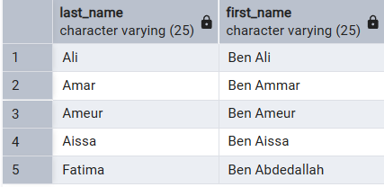
RAPPORT LAB 2 :
The goal of this lab is to master retrieving, filtering, and aggregating data from the University database using SQL. AND mention that this lab focuses on the 26 required queries listed in the manual
1. List the last names and first names of all students
SELECT
Last_Name,
First_Name
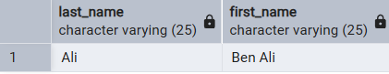
FROM Student;
2. Students who live in a chosen city (example: Algiers)
SELECT
Last_Name
First_Name
FROM Student
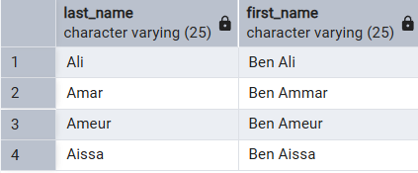
WHERE City = 'Algiers';
Algiers is just an exemple .
3. Students whose last name starts with 'A'
SELECT Last_Name, First_Name
FROM Student
WHERE Last_Name LIKE 'A%';
4. Teachers whose second-to-last letter of the last name is 'E'
SELECT Last_Name, First_Name
FROM Instructor
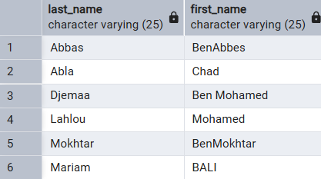
WHERE Last_Name LIKE '%E_';
“we have no instructor that second last letter of his last name is E”
5. Teachers sorted by department, then last name, then first name
SELECT Last_Name, First_Name
FROM Instructor
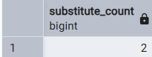
ORDER BY Department_ID, Last_Name, First_Name;
6. How many teachers have the grade ‘Substitute’?
SELECT COUNT(*) AS Substitute_Count
FROM Instructor
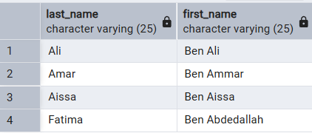
WHERE Rank = 'Substitute';
7.student who don’t have a fax number
SELECT SELECT Last_Name, First_Name

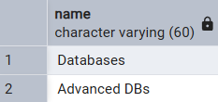
FROM Student
WHERE Fax IS NULL;
8. Titles of courses whose description includes ‘Licence’
SELECT Name
FROM Course
9.
SELECT
C.Name,
SUM(R.Hours_Number * 3000) AS Cost_DA
FROM Course C
JOIN Reservation R
ON C.Course_ID = R.Course_ID
AND C.Department_ID = R.Department_ID
GROUP BY C.Name;
--10
SELECT Name
FROM (
SELECT
C.Name,
SUM(R.Hours_Number * 3000) AS Cost_DA
FROM Course C
JOIN Reservation R
ON C.Course_ID = R.Course_ID
AND C.Department_ID = R.Department_ID
GROUP BY C.Name
) AS Course_Cost
WHERE Cost_DA BETWEEN 3000 AND 5000;
11. Average and maximum room capacity
SELECT
AVG(Capacity) AS Average_Capacity,
MAX(Capacity) AS Max_Capacity
FROM Room;
12. Rooms with capacity less than the average.
SELECT Building, RoomNo, Capacity
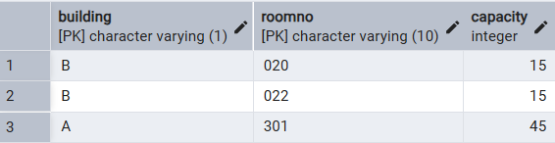
FROM Room
WHERE Capacity < (
SELECT AVG(Capacity)
FROM Room
);
13. Teachers in departments ‘SADS’ or ‘CCS’
SELECT Last_Name, First_Name
FROM Instructor
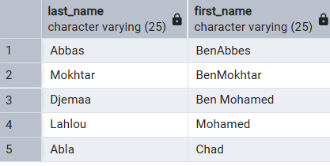
WHERE Department_ID IN (
SELECT Department_ID
FROM Department
WHERE Name IN ('SADS', 'CCS')
);
14. Teachers NOT in ‘SADS’ nor ‘CCS’
SELECT Last_Name, First_Name
FROM Instructor
WHERE Department_ID NOT IN (
SELECT Department_ID
FROM Department
WHERE Name IN ('SADS', 'CCS')
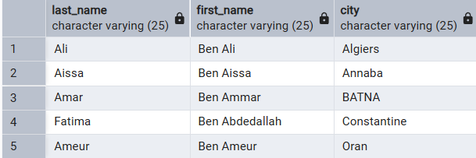
);
15. Sort students by city
SELECT Last_Name, First_Name, City
FROM Student
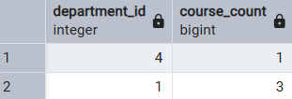
ORDER BY City;
16.
SELECT Department_ID, COUNT(*) AS Course_Count
FROM Course
GROUP BY Department_ID;
17. Departments with >= 3 courses
SELECT Department.Name
FROM Department, Course
WHERE Department.Department_ID = Course.Department_ID
GROUP BY Department.Name 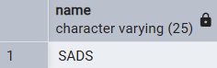
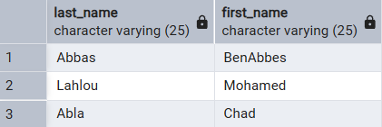
HAVING COUNT(*) >= 3;
18. Teachers with at least two reservations (EXISTS)
SELECT Last_Name, First_Name
FROM Instructor
WHERE EXISTS (
SELECT 1
FROM Reservation
WHERE Reservation.Instructor_ID = Instructor.Instructor_ID
GROUP BY Reservation.Instructor_ID
HAVING COUNT(*) >= 2
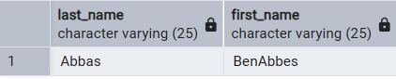
);
19. Teachers with the MOST reservations (using ALL)
SELECT I.Last_Name, I.First_Name
FROM Instructor I
JOIN Reservation R ON I.Instructor_ID = R.Instructor_ID
GROUP BY I.Instructor_ID, I.Last_Name, I.First_Name
HAVING COUNT(*) >= ALL (
SELECT COUNT(*)
FROM Reservation
GROUP BY Instructor_ID
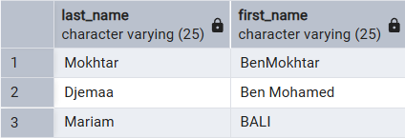
);
20. Teachers with NO reservations
Teachers with the MOST reservations (using ALL)
SELECT I.Last_Name, I.First_Name
FROM Instructor I
JOIN Reservation R ON I.Instructor_ID = R.Instructor_ID
GROUP BY I.Instructor_ID, I.Last_Name, I.First_Name
HAVING COUNT(*) >= ALL (
SELECT COUNT(*)
FROM Reservation
GROUP BY Instructor_ID
);
21. Rooms reserved on ALL dates
SELECT Building, RoomNo
FROM Reservation
GROUP BY Building, RoomNo
HAVING COUNT(DISTINCT Reserv_Date) = (
SELECT COUNT(DISTINCT Reserv_Date)
FROM Reservation
);
“there is no rooms reserved all dates”
conclusion:
Conclude by stating that the DML queries confirm the database integrity rules (Primary/Foreign keys) are working correctly and that the data is ready for the Advanced SQL phase (Functions and Triggers).

